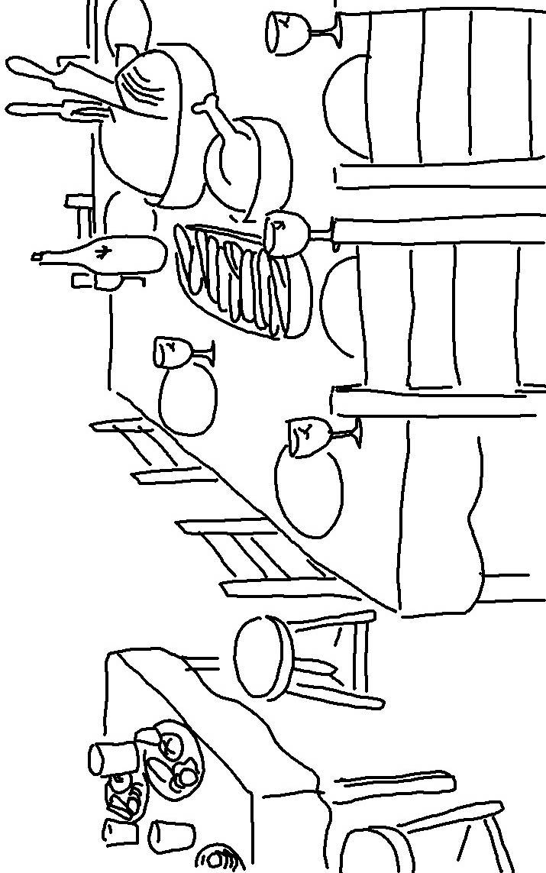
I will _ _ _ _ _ those who _ _ _ _ _ me.1 Samuel 2:30

